# **BCIT**

**Comp 4952 HCI for Application Development**

**Technical Programming Option**

# **Option Head Mirela Gutica**

**Fall 2022**

Mark: ________ /20

Lab 1

**Heuristics of HCI: Interface Design**

This is a **small team project**. Form groups of 2 or 3 students. The assignment should be handed-in no later than 11:30 pm Monday September 12, 2022**. No late assignments will be accepted**.

**Requirements**:

Mandatory readings:

· The Eight Golden Rules of Interface Design (Shneiderman, 2016).<https://www.cs.umd.edu/users/ben/goldenrules.html>

· 10 Usability Heuristics for User Interface Design<http://www.useit.com/papers/heuristic/heuristic_list.htm>l (Nilesen, 2005)

· Principles of Interaction Design. [http://asktog.com/atc/principles-of-i](http://asktog.com/atc/principles-of-interaction-design/)<http://www.useit.com/papers/heuristic/heuristic_list.htm>[nteraction-design/](http://asktog.com/atc/principles-of-interaction-design/) (Tognazzini, 2014).

· Fitts’s Law (notes).

Consider (1) a past project of yours **AND** (2) an application (e.g., a website) of your choice (for example you can choose a website that you like a lot, or dislike a lot).

**A.** **Describe the project & application (Meetup.com - Application):**

Meetup.com is a social media platform for hosting and organizing in-person events for people with similar interests. Users can login to host or join events in a certain location. Overall, it is a very popular website that is maintained and polished to be up to date and user-friendly.

[Meetup - We are what we do](https://www.meetup.com/)

**B.** **Answer the questions (Meetup.com - Application):**

For each question include a short description and screenshots:

1. What of the eight golden rules of interface design are or are not implemented?

**o 1: Strive for Consistency. IMPLEMENTED**



Header always remains at the top of the page, on every page of the website

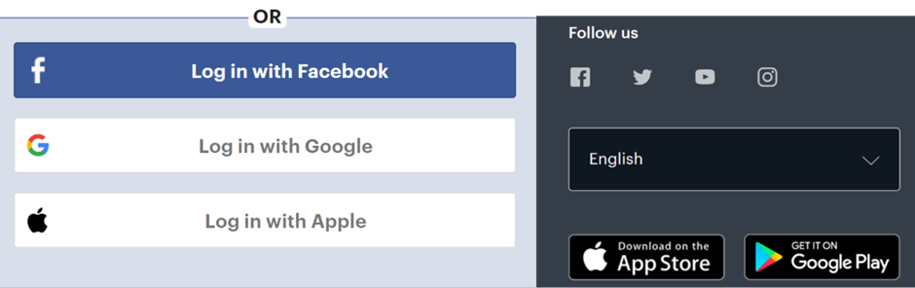

Login in offers methods common with many other websites and applications that have accounts

**o 2: Seek universal usability. IMPLEMENTED**

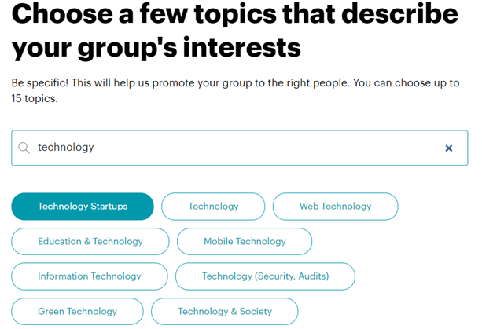

When creating a group, website offers topics that help the user describe and tag the event for specific categories/people

**o 3: Offer informative feedback. IMPLEMENTED**



Hovering over buttons

**o 4: Design dialogs to yield closure. NOT IMPLEMENTED**

Unable to find any dialogs before making any important actions. When a user leaves the page while creating an event, it saves all the information and steps before it, but doesn’t alert the user.

**o 5: Prevent errors. IMPLEMENTED**

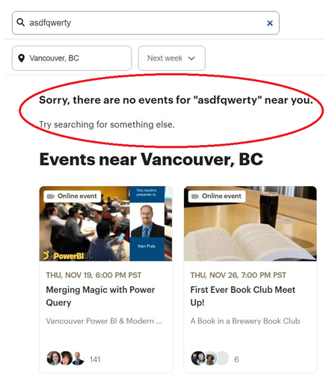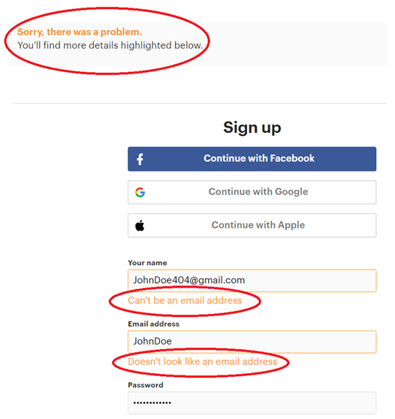

**o 6: Permit easy reversal of actions.**

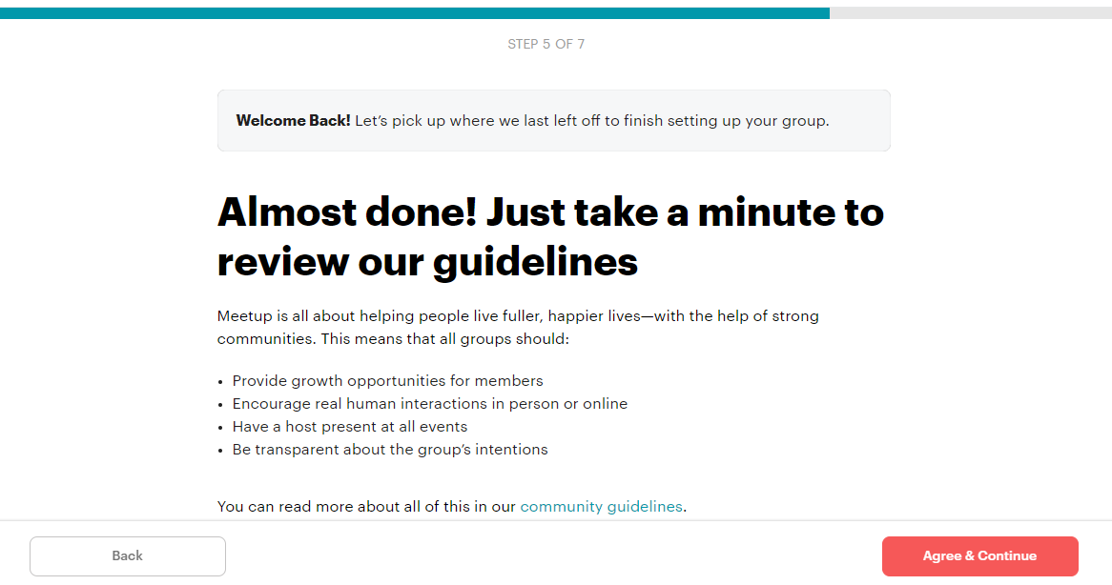

Creating a group is a step-by-step process and intuitive

**o 7: Keep users in control. IMPLEMENTED**

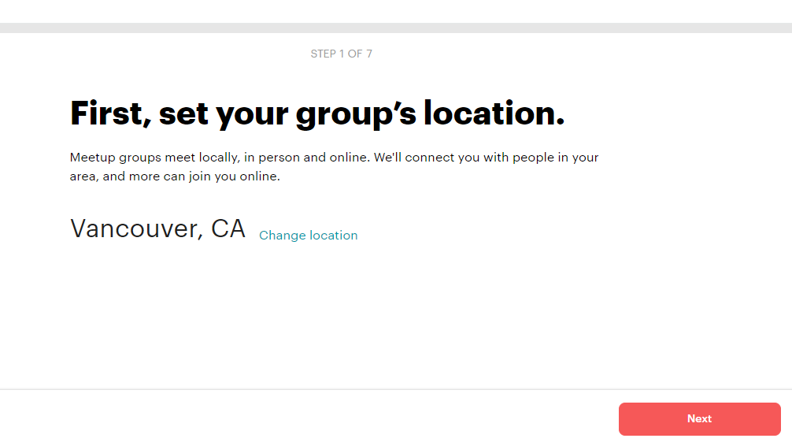

Automatically and manually allow users to change their base location

**o 8: Reduce short-term memory load. NOT IMPLEMENTED**

2. What of the 10 usability heuristics of interface design (not included in the previous set of rules) are or are not implemented?

**o 1: Visibility of system status**

When meetup.com first loads, it prioritizes displaying the splash screen. Light grey boxes are shown in place of content. These grey boxes act as placeholders to indicate that the page is still obtaining page resources from the database and information is loading.

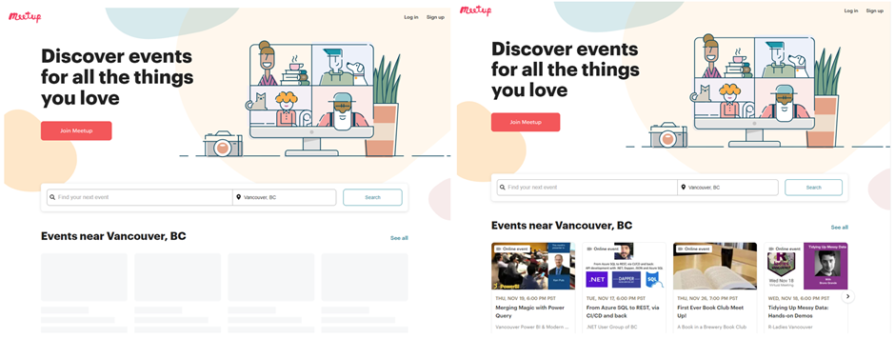

This helps users with a slower internet connection stay informed that the content is loading.

Also, this button subtly lightens in colour when the user hovers their cursor over the button to be responsive to users.



**o 2: Match between system and the real world**

When a user clicks into the Tech events section, they are immediately displayed events with specific keywords relevant to users. Here, a technology related term (“Power Query”) is shown which only tech savvy users would understand and be interested in.

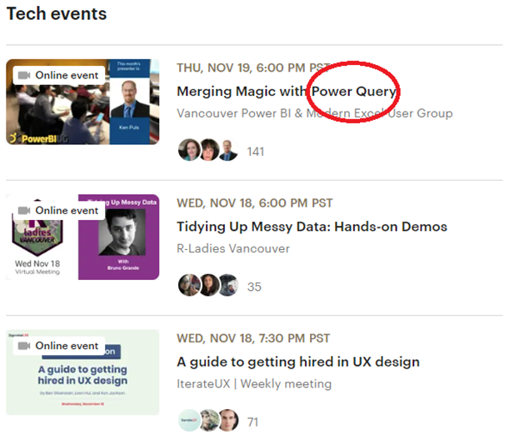

**o 3: User control and freedom**

Meetup.com implements plenty of visible exis and back buttons on the process page when a user is trying to create a Meetup group

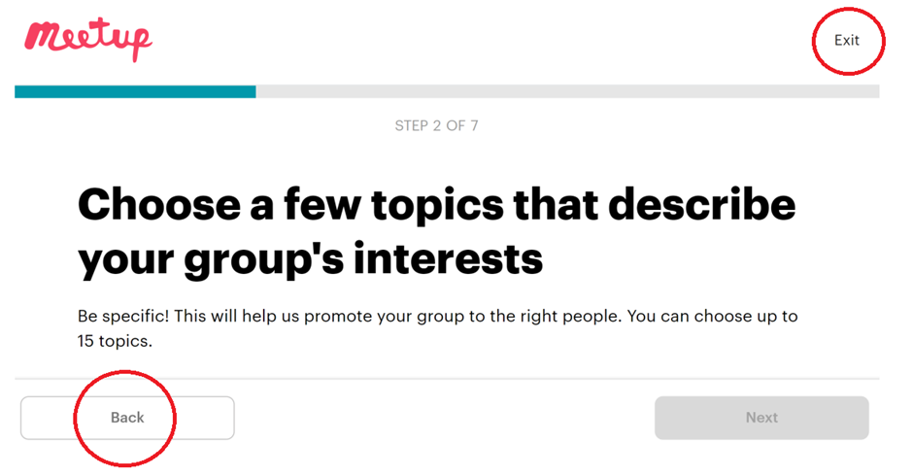

**o 4: Consistency and standards**

Meetup.com uses consistent designs and colour schemes for the website. Users can find red buttons on all the pages as seen from the numerous screenshots here

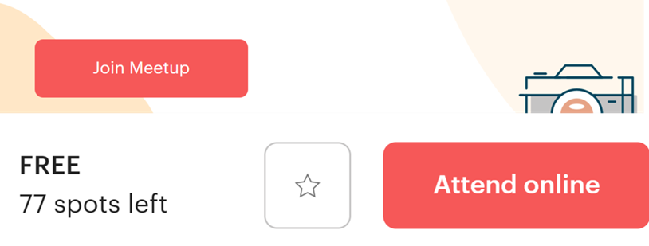

**o 5: Error prevention**

The first thing users might do on the website is try to login or create an account. The login and registration feature has plenty of alert that prevent users from making errors.

While the user is typing, there are alerts stating that email and password fields are mandatory.

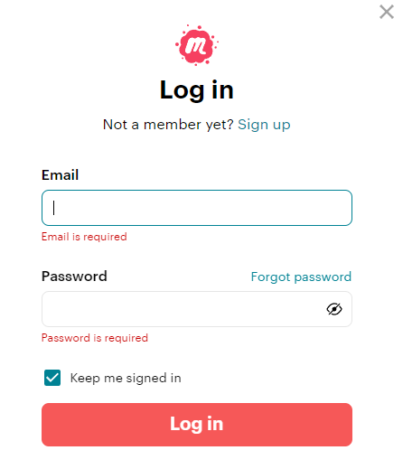

When a user submits empty or incorrect fields (in this case I used a username instead of an email), a pop-up says that it should be an email with an “@” symbol 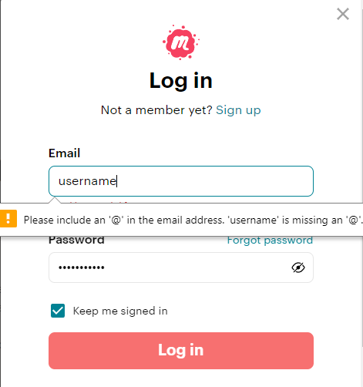

**o 6: Recognition rather that recall**

When creating an event, the website recognizes the users location rather than having the user type out the location of their event completely



**o 7: Flexibility and efficiency of use**

When setting up a new group, a field that requires user input is searching for keywords that describe the group. This feature is used to better target the users audience. There is a feature where words are automatically shown while typing out a partial term in the search bar



**o 8: Aesthetic and minimalist design**

On the homepage of the website, users are only shown 4 events near their area as starting recommendation events for them to not overwhelm users with events, which might help them dive deeper into a more suitable event

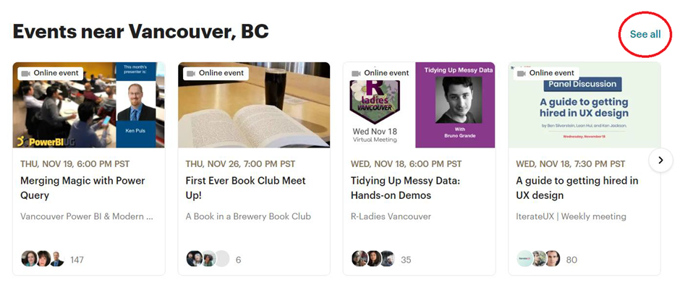

**o 9: Help users recognize, diagnose, and recover from errors**

When entering incorrect credentials on the signup page, users are given the appropriate alerts and feedback



**o 10: Help and documentation**

Meetup.com includes a fully functional and useful help page with a search query and six broad topics for issues

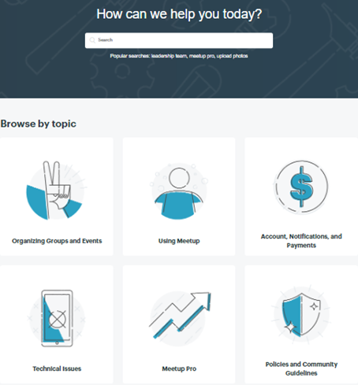

3. What of the Tognazzini’s principles of interface design (not included in the previous two sets of rules) are or are not implemented? **Choose 5 principles.**

* 1: Anticipation **(INCLUDED)**

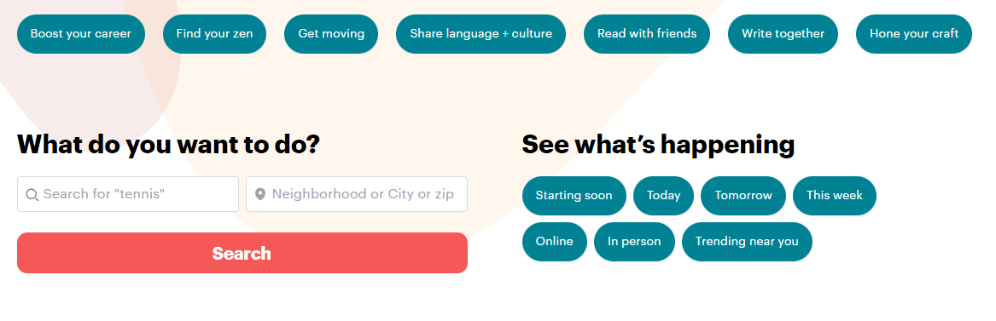

Meetup.com has many starting redirect buttons with recommended tags to users first starting off on the homepage of the website looking for groups

* 2: Color **(INCLUDED)**

Website only uses very contrasting colours (white,black, red buttons, blue tags). For color blindness, the website only uses more rectangular shaped buttons (as seen in the many examples above) for user controlled actions, and more rounder buttons for tags that redirect to specific groups/events

* 3: Defaults **(INCLUDED)**



Searching up key words displays popular and common tags for events/groups

* 4: Discoverability **(INCLUDED)**



Front page home screen will only display relevant events near you, and only four at a time with an option to see more as to limit the user.

* 5: Human Interface Objects **(INCLUDED)**

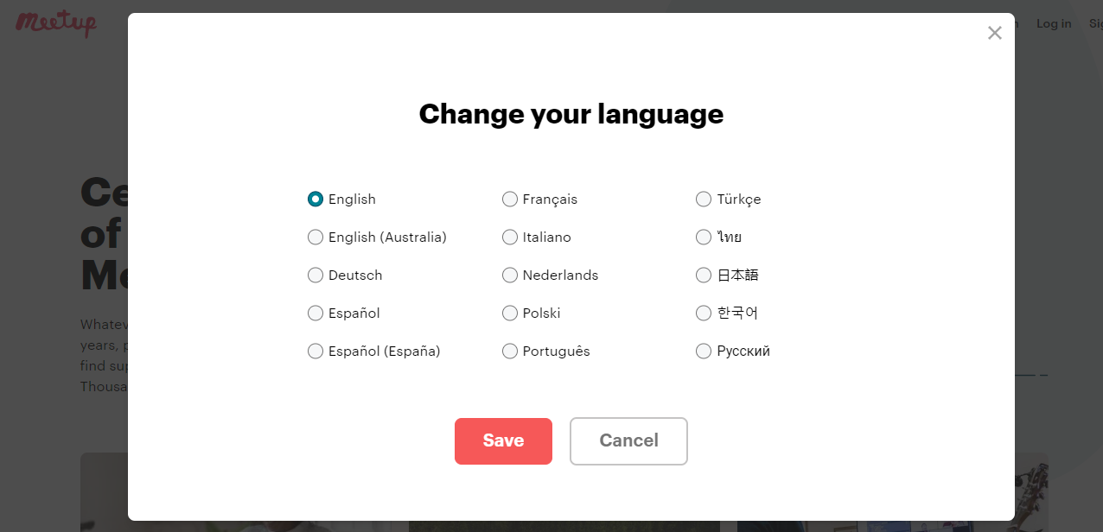

Clicking the change language option (has a “globe” icon to indicate itself) opens a pop-up with common languages in their own respective languages to be open to more users.

4. What would you/the authors have done differently to improve usability?

o Add a button at the top of the header to be able to create a group immediately without having to scroll a lot on the homepage

5. What technical difficulties do you see when you/the authors design a better user experience in this project/application?

o Creating grpahics/UI/icons in many sizes/quality

o Routing and redirecting users based on certain fields

**C.** **Describe the project & application (PlantiFind - Project):**

PlantiFind was an app developed for the one month COMP 2800 2021 project term in a team of 2 term 1 and 2 term 2 students. It is a mobile and web app that displays a community map (using the Google Maps API) of user uploaded images of plants. It also recognizes images of plants users upload to the map using a plant identifier API to display some information about that plant.

[PlantiFind](https://plantifind.netlify.app/#/login)

**D.** **Answer the questions (PlantiFind - Project):**

For each question include a short description and screenshots:

1. What of the eight golden rules of interface design are or are not implemented?

**o 1: Strive for Consistency. Not Implemented.**

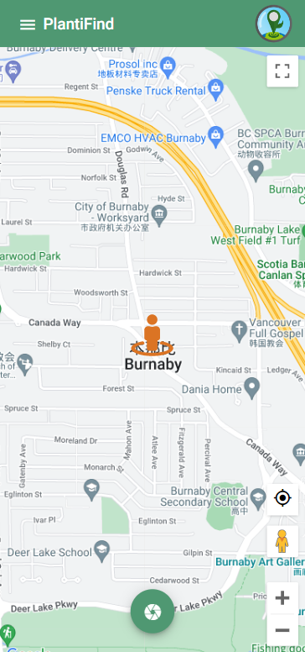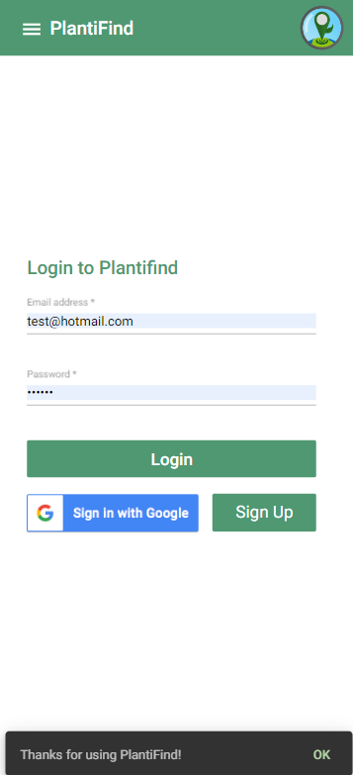

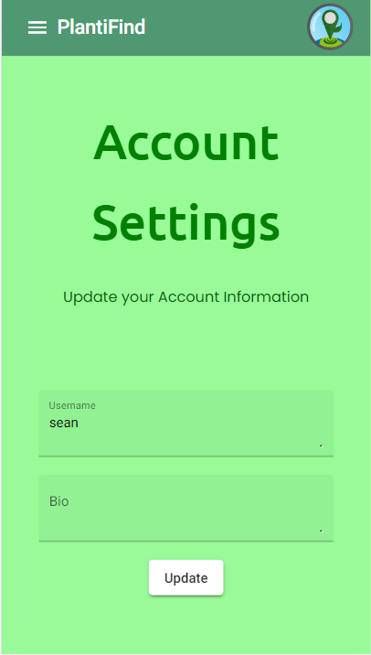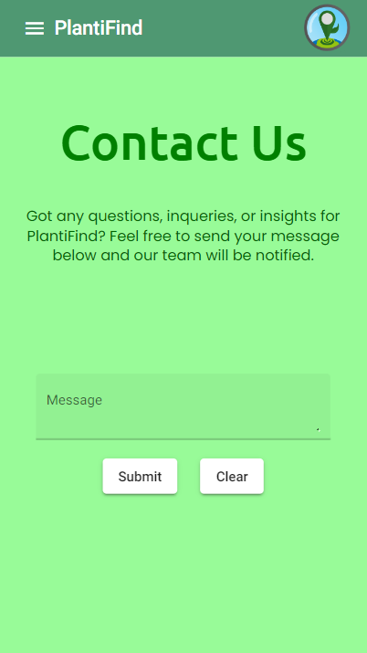

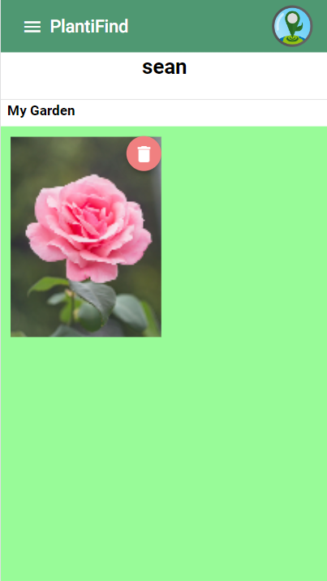

Each screen uses similar colours and font size throughout the app; except for the Gallery page. The font colour and size is different from all other pages. The font size is smaller and the colour of the text is black while the others are in green colour. The Gallery page also lacks the footer bar which every other page has.

**o 2: Seek universal usability.**



**o 3: Offer informative feedback. Implemented**.  
When signing up the ‘Sign up’ button has a pressed animation. But more importantly, after inputting a 4 character password; an alert dialogue appears. The alert dialogues lets the user know the password is not sufficient and what is sufficient for a password.

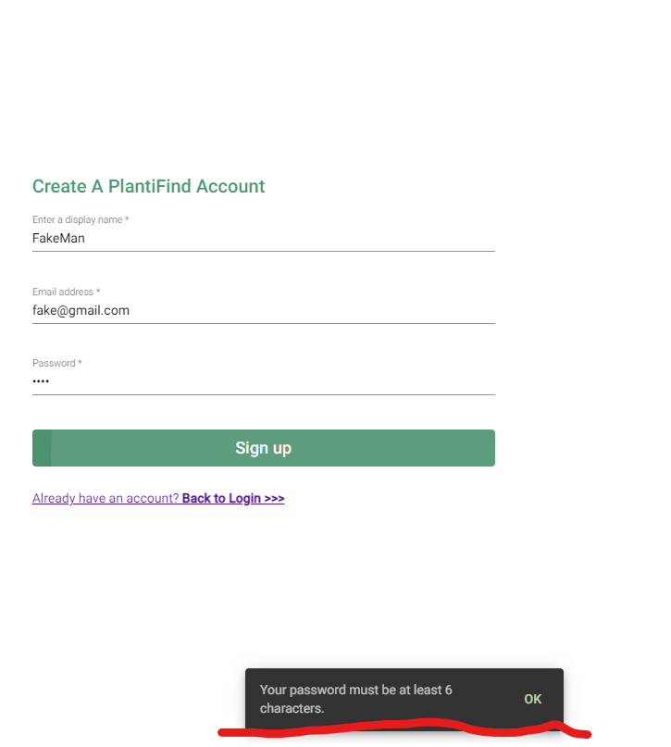

**o 4: Design dialogs to yield closure. Implemented**

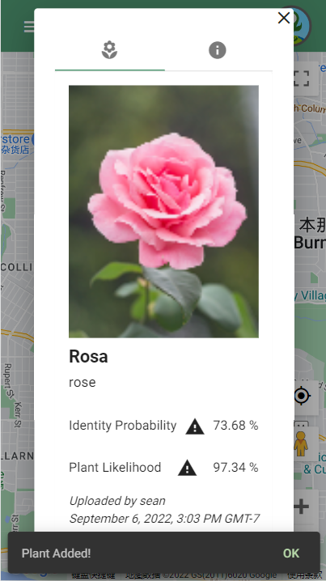

The app has informative feedback while you plant the tree and logging out the app. As the graph above shows, when you successfully plant a tree, it pops up a grey alert box with Plant Added text to let users know that their actions are successful without going to check the gallery page or click on the pointer on the map. And it also has the alert box popping up with a “Thanks” prompt for using PlantiFind! When users log out the app gives closure of the procedure..

**o 5: Prevent errors. Implemented.**

When uploading a plant for a certain location, an API tries to decipher the species of the plant. After getting the plant species data from the API, Plantifind asks the user if its result is true. And in picture 2, if the result is not true, Plantifind provides alternative options that it could be. By doing this, it prevents the user from uploading the picture with the wrong plant species associated with it; which would be a serious error.

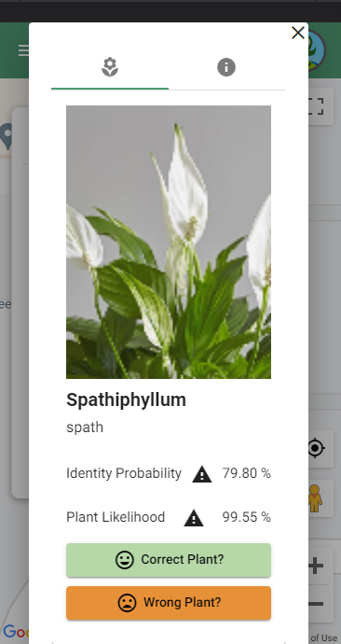

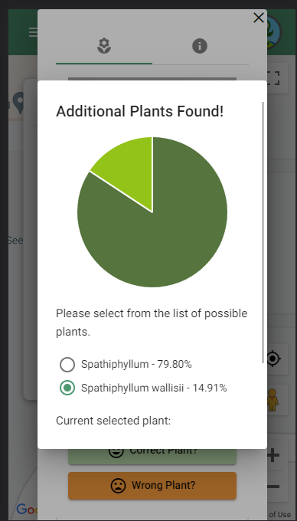

**o 6: Permit easy reversal of actions. Implemented**

At all steps of the plant picture uploading process, none of the options are set in stone until the upload is confirmed. Whether choosing the image to upload (Picture 1), confirming the suspected plant species (Picture 2), or choosing another plant species (Picture 3); all steps in this process can be reversed to choose different options.

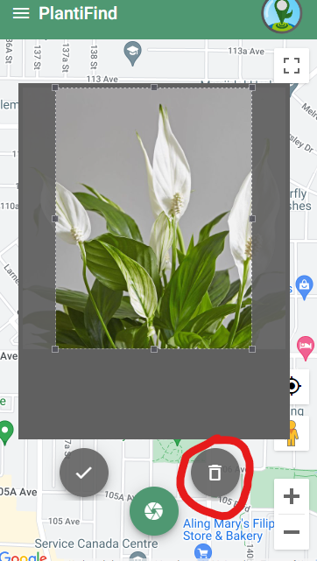

*Picture 1: Trash icon to reject the photo.*

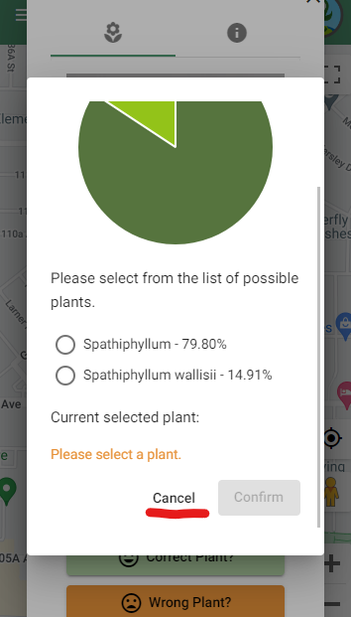

*Picture 2: Cancel button to previous step for choosing alternate plant species.*

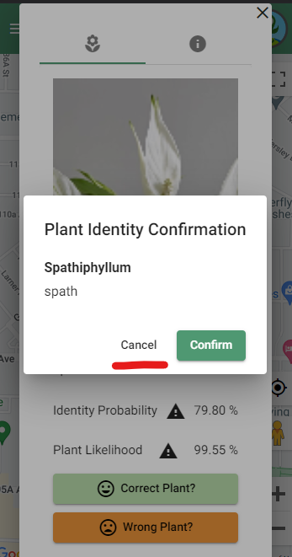

*Picture 3: Cancel button to previous step for plant species confirmation.*

**o 7: Keep users in control. Not Implemented**

Most of the app is functionally very good and does what it is supposed to do, except for cancelling a photo upload of a plant for a location. Below, Picture 1 shows the screen right before uploading a picture of a plant. Upon hitting the cancel button, the photo and its info are uploaded to the app shown on Picture 2. The user is in no way in control of the uploading process and even tried to cancel it. So inherently, the user is not in control.

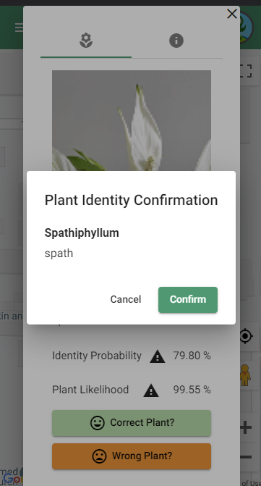

*Picture 1: Plant species confirmation screen.*

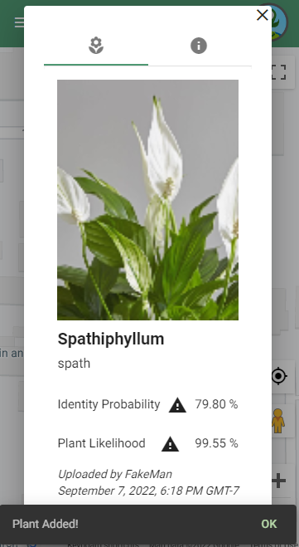

*Picture 2: Plant is inserted onto map after cancelling.*

**o 8: Reduce short-term memory load. Implemented/Not Implemented**

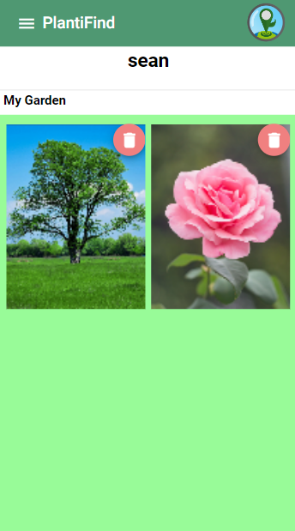

*Gallery of photos. Although, no data in relation to them is present.*

The Gallery page has all the history of my plants that I planted before so I don’t have to memorise all the plants I have. However, if each plant on this page can have the address information with its picture, it would be better.

2. What of the 10 usability heuristics of interface design (not included in the previous set of rules) are or are not implemented?

**o 1: Visibility of system status**

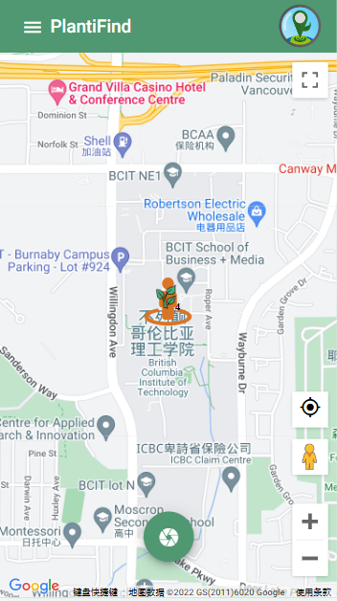

The map has the indicators to let users know where they are on the map and also the indicator for their plants, so the user has a clear idea of where they are currently located on the map and where the plants are located.

**o 2: Match between system and the real world**

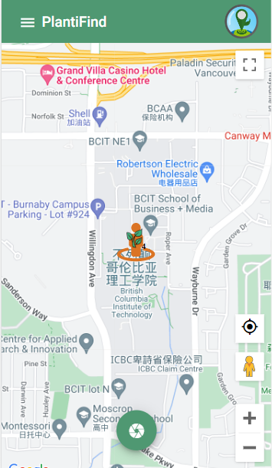

When users first log into this app, it is likely they will not understand the functionality of the green button on the bottom of the map. The meaning of the button is not clear, so users will hesitate and be cautious to tap the button. The functionality of the button is to upload a picture from your device, which is not recognizable to most.

**o 3: User control and freedom**

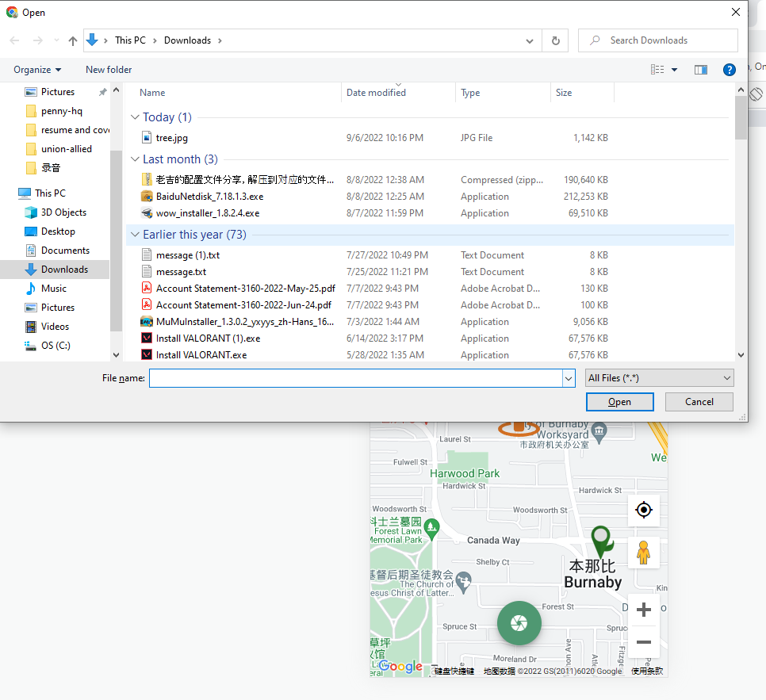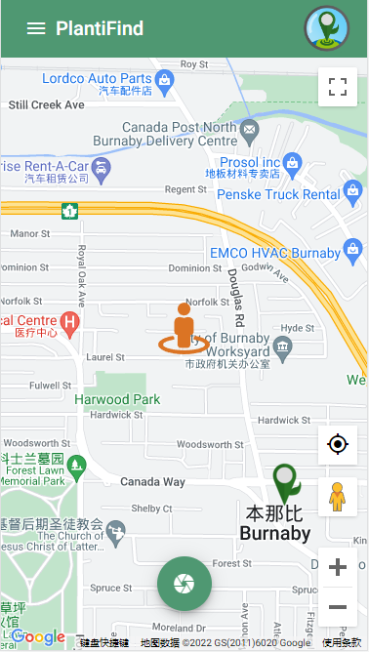

If a user accidentally clicks the button on the bottom of the map, users will see the Windows Explorer screen appear. If users don’t wanna go through the whole process, they can click cancel and it will bring them back to the map view.

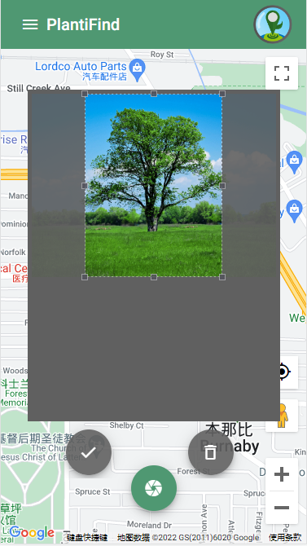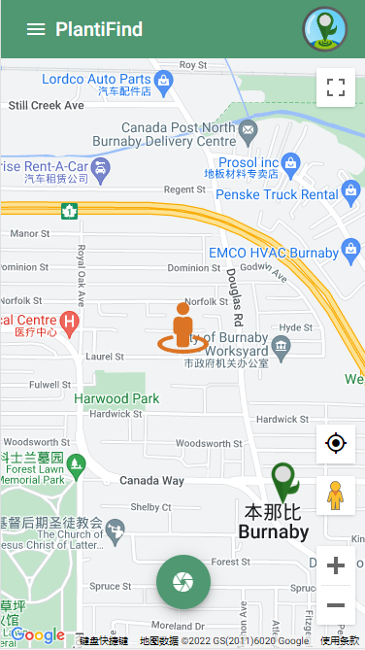

Let’s assume the user chooses the wrong picture for the plant. If users click the trash bin button below the image, it will bring you back to the map.

**o 4: Consistency and standards**

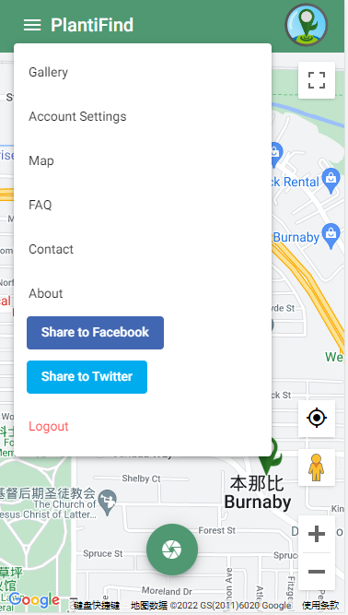

The burger menu of this app has the correct order of menu options, it has the plant management in the first place, and account setting second then map, FAQ, contact and about page, is the same as the majority of the web page that we view before.

**o 5: Error prevention**

**o 6: Recognition rather than recall. Implemented.**

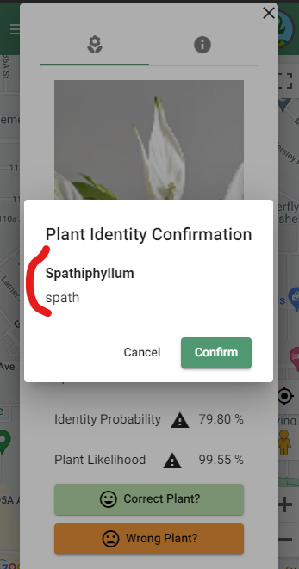

After the user has made their selections whether the plant species is different or correct, the confirmation dialog shows the user plant’s identity and species. The user does not have to remember the info prior to this menu. The user recognizes the options they choose during the upload process rather than trying to recall it.

**o 7: Flexibility and efficiency of use. Implemented.**

The process of uploading a picture can be accelerated. The buttons are interactable with keyboard keys such as the Enter key (click a button) and Tab key (move to next button selection). For experienced users, this speeds up the process by not wasting time moving the mouse across the screen constantly.

**o 8: Aesthetic and minimalist design**

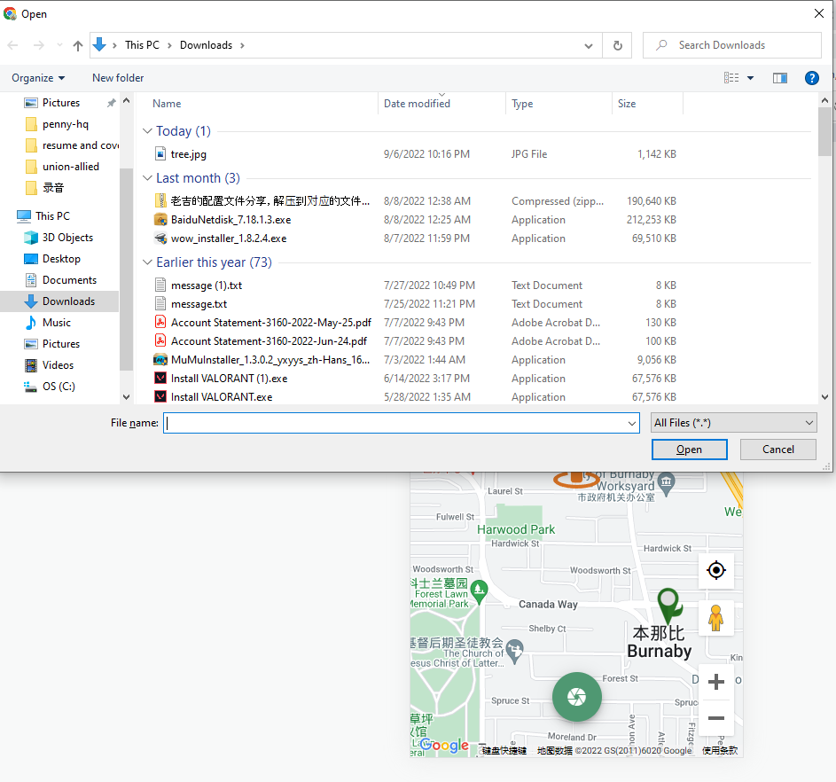

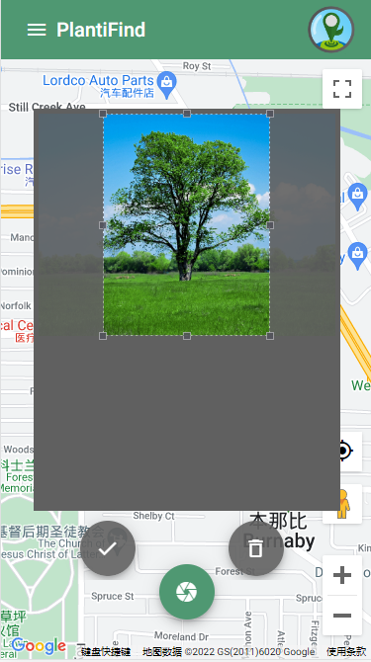

Once user click the only button at bottom of the map it will go to upload window, and when u select the pic file and click open it will show you the picture and u can confirm or delete, if delete will bring user back to the main page which is the map, if click ok it will let user know they successfully plant a tree, and generate an indicator of the plant on map. All the content is very focused.

**o 9: Help users recognize, diagnose, and recover from errors. Implemented**

An alert pops up and informs the user of their faulty password and how to fix it.



**o 10: Help and documentation**

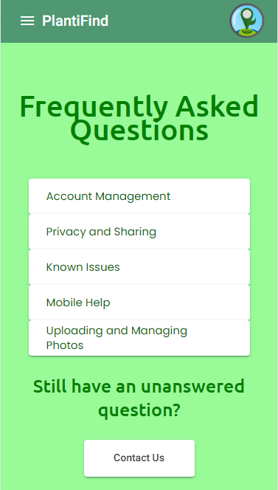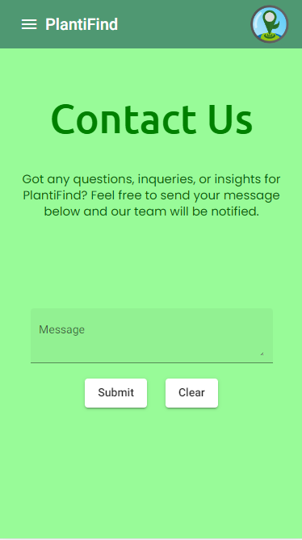

The app has a FAQ and contact us page which lets users ask questions if they have any issues with the app.

3. What of Tognazzini's principles of interface design (not included in the previous two sets of rules) are or are not implemented? **Choose 5 principles.**

* **Principle 1: Fashion should never trump usabilit**y

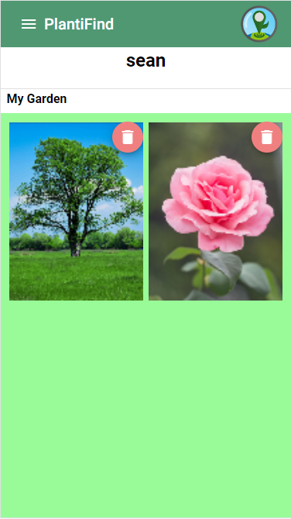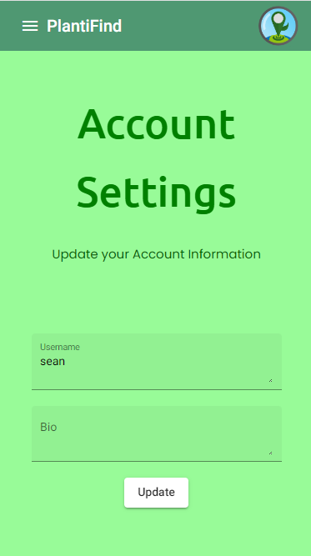

The whole app is structured with pretty simple design with solid usability. Easy for users to use this app.

* **Principle 2: Bring to the user all the information and tools needed for each step of the process**

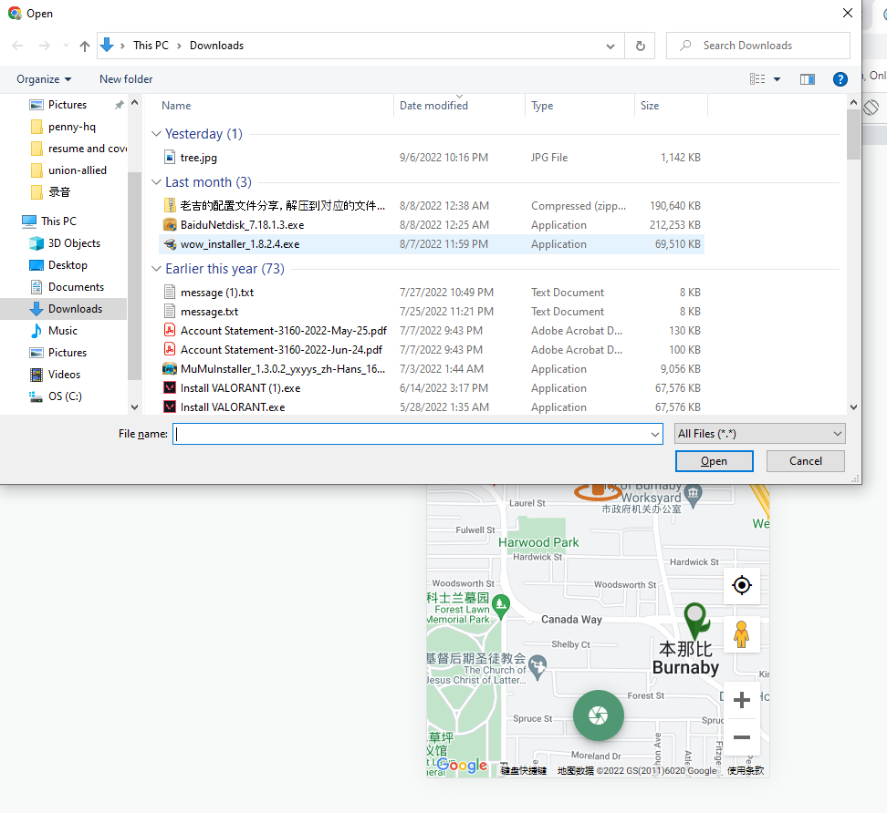

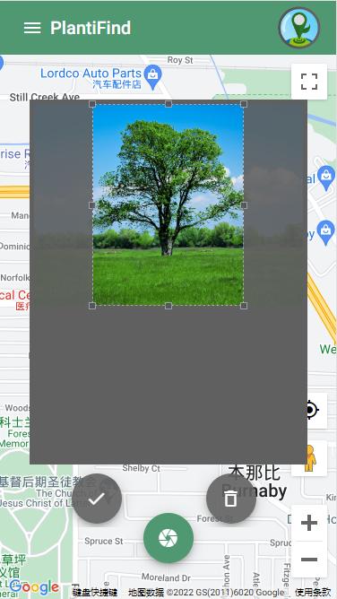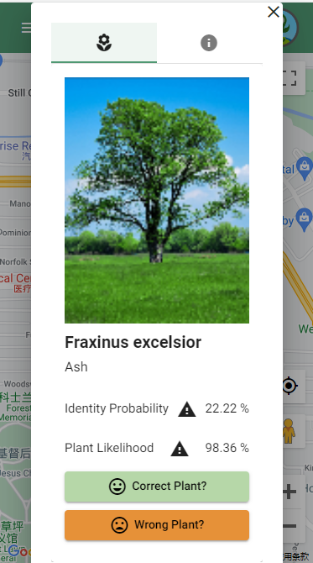

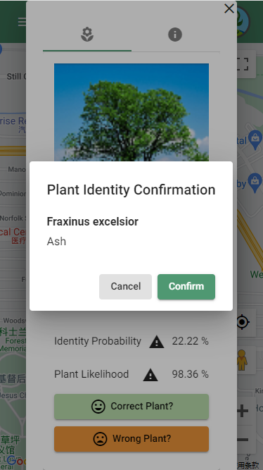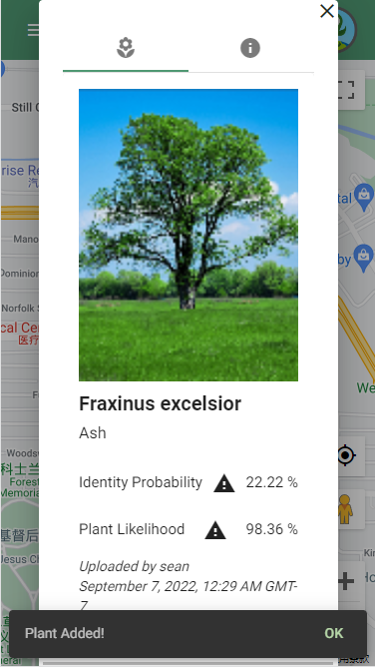

The app has very clear information for every step of the process.

* **Principle 3:** **Always allow “Undo” -** Plantifind’s important features do not have undo options after the fact. After uploading a picture to the map, there is no “undo” button after that process. Instead the process comes with confirmation dialogs. A worse case of a non-present “undo” option is in the photo gallery of the user. Deleting a picture you uploaded (and its map data) does not yield an “undo” or a confirmation dialog. Once that delete button is pressed, that picture is gone forever.

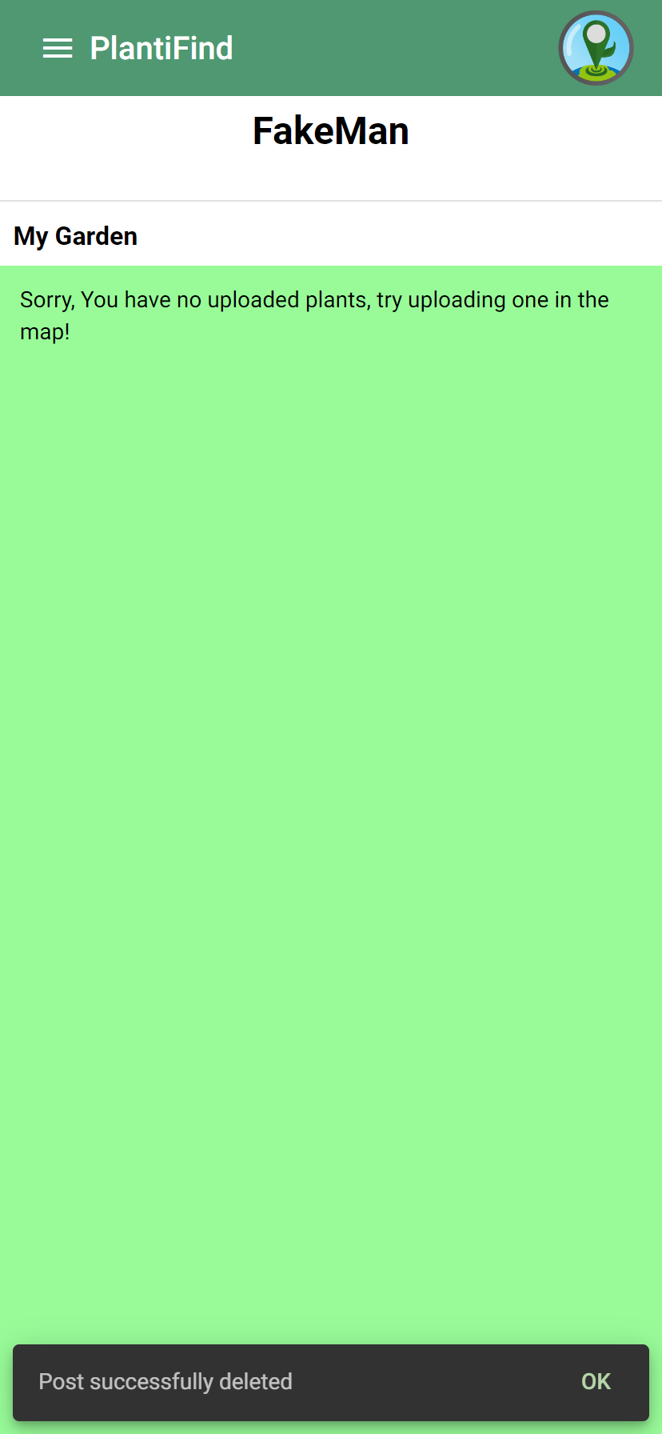

*Confirmation dialogs but no undo option.*

* **Principle 4: Sometimes you do have to provide deep ruts -** There is no tutorial for novice users for how to use the map and what the upload button is. Below is the view of what the user will see when they register and log in. There are no tutorials or directions for novice users using an app like this for the first time.

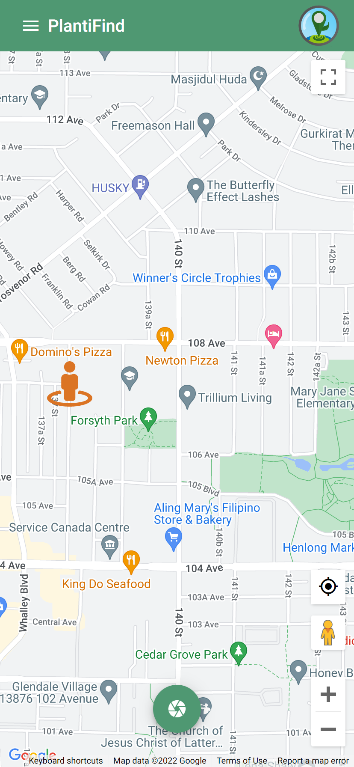

*Landing page with no direction.*

* **Principle 5: Offer users stable perceptual cues for a sense of “home” -** The header bar and logo button are stable elements which never leave the top of the screen of the app (Pictures 1 & 2). Although these elements are not perfect, scrolling down on certain pages will cause those elements to disappear (Picture 3). Therefore, they did some right and wrong in their design of this concept.

 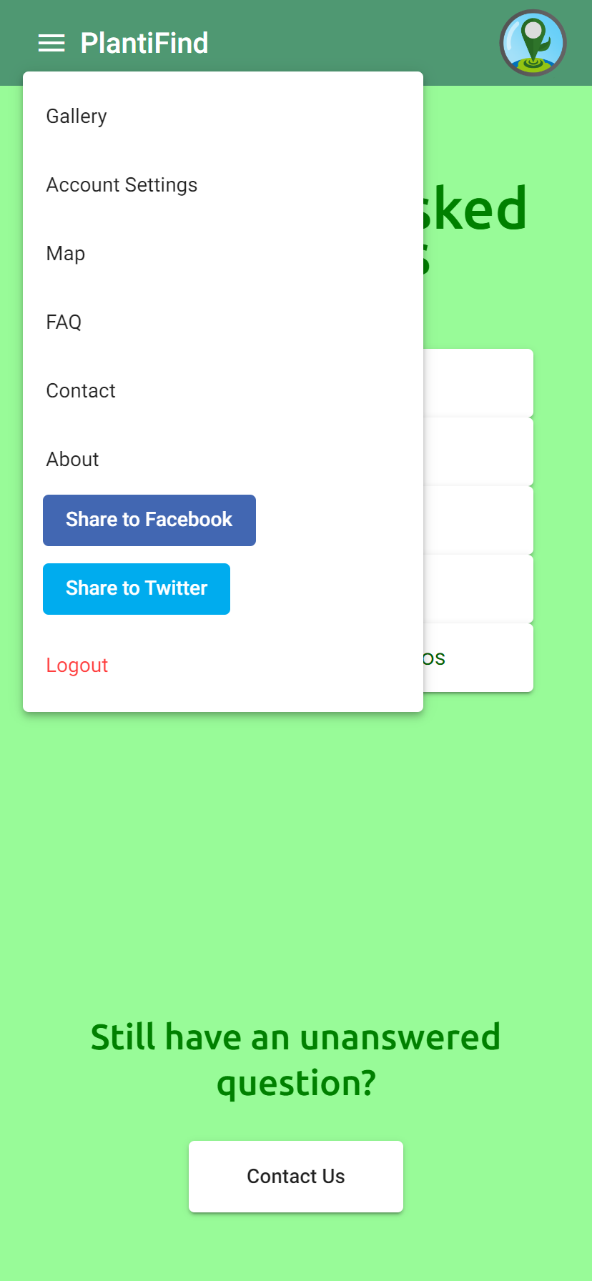

*PIcture 1 (left) & Picture 2 (right) - Header Bar present.*

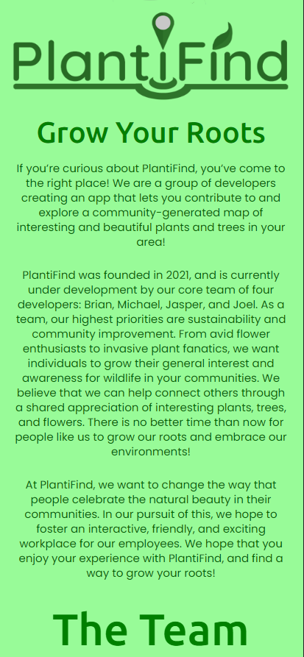

*Picture 3 - No header bar present.*

4. What would you/the authors have done differently to improve usability?

Regarding the prior mentioned attribute:

* **offer users stable perceptual cues for a sense of “home” -** the header should stick to the top of the screen when scrolling down certain pages; no exceptions. It is too important for easy access to features and for its comfort to users.
* **usability heuristic #2: match between system and the real world -** make this more clear. Change the icon to upload text or some icon that is more clearly related to upload functionality.

5. What technical difficulties do you see when you/the authors design a better user experience in this project/application?

* For an “undo” button, they would have to keep ahold of the state on the prior screen and be ready to navigate back to it. I am also guessing the logic would wait a few seconds before POSTing the data to the database. This will add some complexity and design choices for the authors.
* Replacing the upload button’s icon should have no difficulties at all